16 апреля 2013 года в 11.00 в аудитории 336 биологического факультета МГУ (кафедра молекулярной биологии) состоится доклад:

«Пространственная структура амилоидных и прионных фибрилл»

STRUCTURAL FOLDS OF AMYLOID AND PRION FIBRILS.
Andrey Kajava, Head of Structural Bioinformatics and Molecular Modelling, CNRS, France.

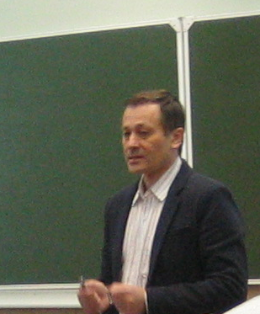
ABSTRACT: Structural details of the amyloid and prion fibrils are keys to developing new therapeutics for neurodegenerative disease such as Alzheimer’s disease, Huntington’s disease, Parkinson’s disease, human prion diseases. Over the past decade, substantial progress has been made in understanding the structural arrangements in amyloid fibrils. Although these specimens remain refractory to the classical approach of X-ray crystallography, progress has stemmed largely from the application of new experimental techniques such as solid state NMR, scanning transmission electron microscopy mass measurements and electron paramagnetic resonance spectroscopy of spin-labelled derivatives. Based on these and other experimental data, several new structural models for amyloid and prion fibrils have been formulated including A-beta amyloid, tau, alpha-synuclein, human amylin, and the fungal prions, Ure2p, Sup35 prions and HET-s. The number of structural data is now large enough to support a systematic analysis. The analysis is making it possible to categorize these structures, yielding an enhanced understanding of their “pathogenic fold” determinants, and is shedding light on how they form and function. The status of this generalization, and its implications, will be central themes of this talk.

