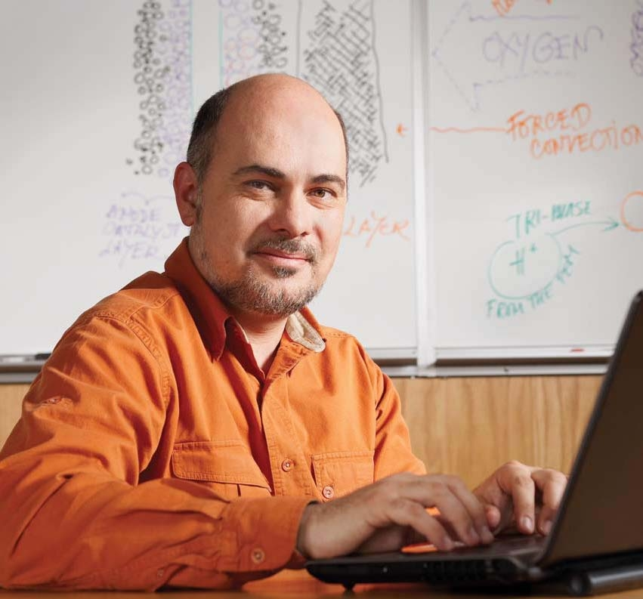
Plamen Atanassov grew up in Bulgaria and graduated from the University of Sofia in 1987 specializing in Chemical Physics and Theoretical Chemistry. He joined the Bulgarian Academy of Sciences and become a Member of Technical Staff of its Central Laboratory of Electrochemical Power Sources (now the Institute for Electrochemistry and Power Systems). His initial work included materials solutions for metal-air batteries. During 1988/89, Plamen Atanassov was a visiting scientist in the Frumkin’s Institute of Electrochemistry, Moscow, Russia studying bio-electrochemistry of enzymes. He received his doctorate from the Bulgarian Academy of Sciences in Physical Chemistry, specializing in Electrochemistry under the guidance of Prof. Ilia Iliev and Prof. Evgeni Budevski.

Plamen Atanassov moved to the United States in 1992 and later became a research faculty with the University of New Mexico. During this period he was involved in development of a several electrochemical biosensor technologies for biomedical, environmental food safety and defense applications. In 1999 Plamen Atanassov joined Superior MicroPowders LLC (now Cabot-SMP) were he was a project leader in fuel cell electrocatalysts development. He returned to the University of New Mexico in 2000 as faculty member of the Chemical and Nuclear Engineering Department.

In October 2007 Plamen Atanassov founded the UNM Center for Emerging Energy Technologies and was its Director till December 2011. Prior to that Plamen Atanassov was UNM Director for the NSF Industry/University Collaborative Research Center. He was the PI on AFOSR MURI “Fundamentals and Bioengineering of Enzymatic Fuel Cells”, which includes faculty from Columbia University, Northeastern University, Michigan State University, St. Louis University and University of Hawaii. Plamen Atanassov is currently the PI of the New Mexico DOE EPSCoR Implementation Award “Materials for Energy Conversion”, a concerted effort of UNM, New Mexico Tech, New Mexico State and Eastern New Mexico Universities. He has standing collaborations with scientists from LANL, SNL, NREL, ANL, ORNL, LBNL and funded programs with industrial partners such as: Toyota/Daihatsu, Ballard, Sharp, Cabot, IRD, CFDRC and Lynntech. Plamen Atanassov ‘s research programs include development of non-platinum electrocatalyst for fuel cells, new materials and technologies for micro-power sources, enzymatic bio-fuel cells, sensor systems design and integration of micro-analytical systems. Starting January 2012 Plamen Atanassov serves as an Associate Dean for Research of the UNM School of Engineering.

