Лекция профессора К.Оказаки

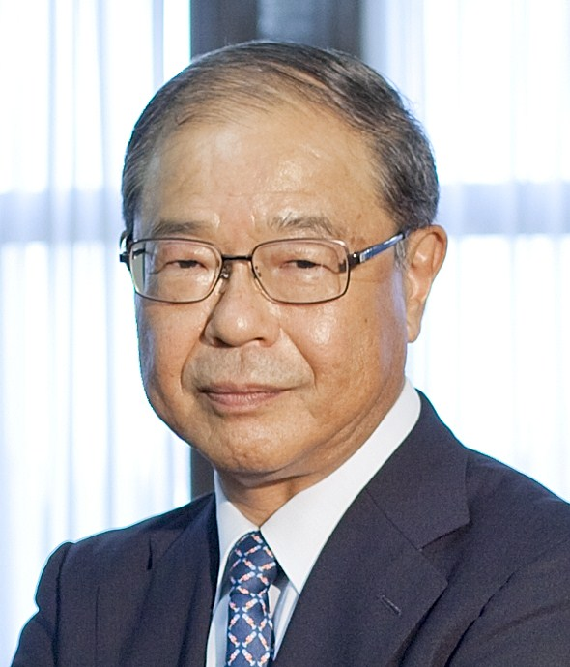

23 мая 2013 года в 15 ч. 00 мин. в ауд.16-24
главного здания МГУ состоится лекция

Sustainable Energy Technologies of Sophisticated Hydrogen Energy Systems and Efficient Use of Wood Biomass
Overview and Fundamentals

Лектор - ведущий мировой эксперт в области водородной и альтернативной энергетики профессор Кен Оказаки (Технологический институт Токио, Япония). Лекция организована Нефтегазовым центром МГУ, совместно с компанией Токио-Боеки и Дирекцией фестиваля науки. Лекция и последующее обсуждение будут проводиться на английском языке.

В докладе будут затронуты следующие вопросы:
1. Global Overview of Energy and Environment
2. Hydrogen Energy Systems
3. Efficient Use of Wood Biomass
4. Integration of Hydrogen Energy Systems with Coal and Biomass

Dr. Ken OKAZAKI
Professor, Department of Mechanical and Control Engineering, Graduate School of Science and Engineering (Former Dean of Engineering), Tokyo Institute of Technology
Japan Professor Ken Okazaki was born in 1949 in Chiba prefecture. He received Doctor of Engineering in mechanical engineering from Tokyo Institute of Technology in 1978. He was with Toyohashi University of Technology from 1978 to 1992 and he has been a professor of Tokyo Institute of Technology since 1992. His research subjects cover a wide range of energy and environmental issues including hydrogen-based advanced energy systems and fuel cells, clean and high-efficiency coal/biomass technologies for global environmental protection, non-equilibrium plasma chemistry and applications for nano-material processing. He received many awards from various academic and industrial societies. He used to be a president of hydrogen society of Japan, vice-president of JSME (Japan Society of Mechanical Engineers) and also he is a chairman of Japan’s national projects related to clean coal technology (CCT) and hydrogen energy systems. He was on a position of Dean of Engineering, Tokyo Institute of Technology for four years until October, 2011. Now, he is a member of the Science Council of Japan.

